Date | 28 September 2026
Team ID | SWTID-2026-7034
Project Name | API FAQ ASSISTANT
Maximum Marks | 4 Marks
Data Flow Diagrams:
A Data Flow Diagram (DFD) is a traditional visual representation of the information flows within a system. It shows how data enters and leaves the API FAQ Assistant, what changes the information, and where data is stored.
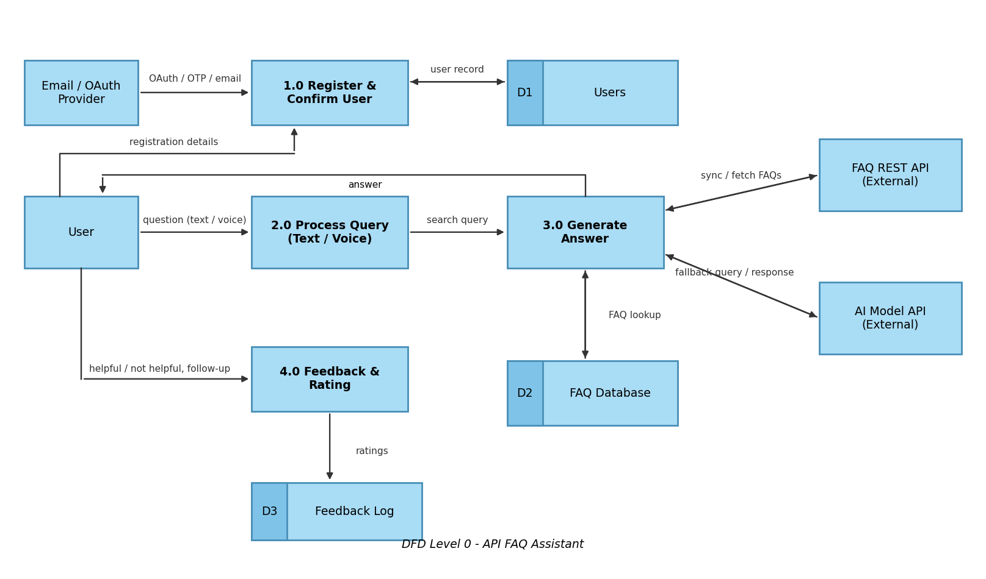
User Stories
User stories for the API FAQ Assistant, based on the functional requirements (FR-1 to FR-6).
User Type | Functional Requirement (Epic) | User Story Number | User Story / Task | Acceptance criteria | Priority | Release
Customer (Mobile user) | Registration | USN-1 | As a user, I can register for the application by entering my email, password, and confirming my password. | I can access my account / dashboard | High | Sprint-1
Customer (Mobile user) | Registration | USN-2 | As a user, I can register for the application through Gmail. | I can register & access the dashboard with Gmail login | Medium | Sprint-1
Customer (Mobile user) | Registration | USN-3 | As a user, I can register for the application through LinkedIn. | I can register & access the dashboard with LinkedIn login | Low | Sprint-2
Customer (Mobile user) | User Confirmation | USN-4 | As a user, I will receive a confirmation email once I have registered for the application. | I can receive confirmation email & click confirm | High | Sprint-1
Customer (Mobile user) | User Confirmation | USN-5 | As a user, I can confirm my registration by entering an OTP. | I can verify my account with a valid OTP | Medium | Sprint-2
Customer (Mobile user) | Login | USN-6 | As a user, I can log into the application by entering email & password. | I can log in and reach my dashboard | High | Sprint-1
Customer (Mobile user) | FAQ Search & Query | USN-7 | As a user, I can ask a question by typing text in the chat interface. | I receive a response to my typed question | High | Sprint-1
Customer (Mobile user) | FAQ Search & Query | USN-8 | As a user, I can ask a question using voice input. | My voice is converted to text and answered | Medium | Sprint-2
Customer (Mobile user) | FAQ Search & Query | USN-9 | As a user, I can search the FAQ database by keyword. | Matching FAQs are listed for the keyword | High | Sprint-1
Customer (Mobile user) | Answer Generation | USN-10 | As a user, I get an answer generated from the FAQ database. | The answer is accurate and shown within 2-3 seconds | High | Sprint-1
Customer (Mobile user) | Answer Generation | USN-11 | As a user, I get an AI-generated answer when no FAQ match is found. | A fallback answer is returned instead of an empty result | Medium | Sprint-2
Customer (Mobile user) | Feedback & Rating | USN-12 | As a user, I can rate an answer as helpful or not helpful. | My rating is saved and confirmed on screen | Medium | Sprint-2
Customer (Mobile user) | Feedback & Rating | USN-13 | As a user, I can submit an additional or follow-up query. | The follow-up is answered in the same conversation | Medium | Sprint-2
Customer (Mobile user) | Dashboard | USN-14 | As a user, I can view my previous questions and answers on my dashboard. | My query history is displayed | Low | Sprint-3
Customer (Web user) | Login | USN-15 | As a web user, I can log into the application from a browser using email & password. | I can log in and reach my dashboard on the web | High | Sprint-1
Customer (Web user) | FAQ Search & Query | USN-16 | As a web user, I can ask questions through the web chat interface. | I receive answers in the web chat window | High | Sprint-1
Customer Care Executive | Feedback & Rating | USN-17 | As a customer care executive, I can view answers rated not helpful. | Low-rated answers are listed for review | Medium | Sprint-3
Customer Care Executive | Dashboard | USN-18 | As a customer care executive, I can view follow-up queries raised by users. | Follow-up queries are visible on my dashboard | Low | Sprint-3
Administrator | API Integration | USN-19 | As an administrator, I can fetch FAQ data via REST API. | FAQ data is loaded into the FAQ database | High | Sprint-1
Administrator | API Integration | USN-20 | As an administrator, I can sync FAQ updates automatically. | New or changed FAQs appear without manual work | Medium | Sprint-2
Administrator | API Integration | USN-21 | As an administrator, I can see API error responses handled gracefully. | Users see a friendly message and errors are logged | High | Sprint-2

